FLAGS  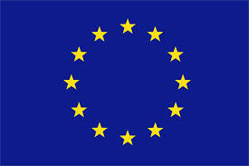 | 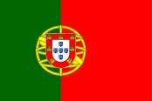 | 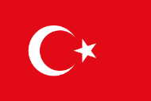 | 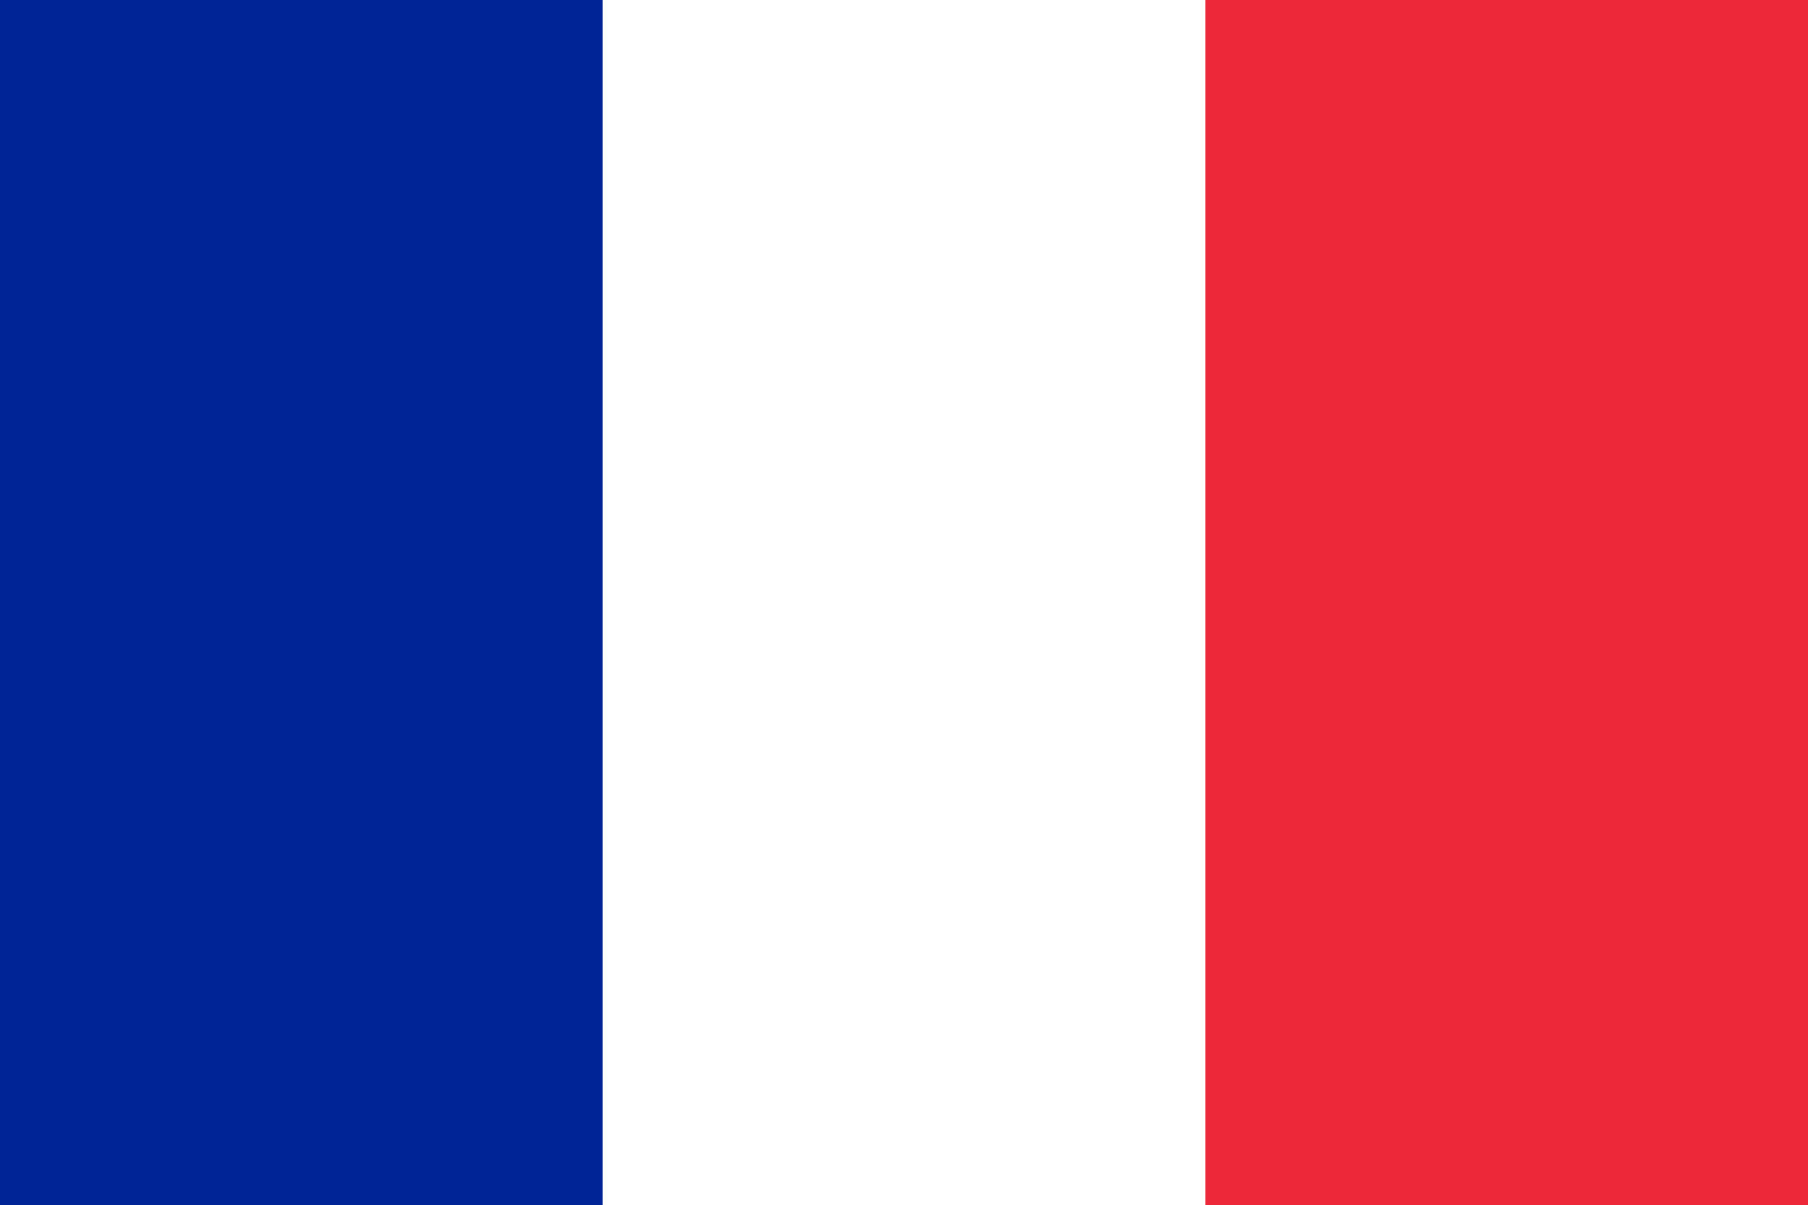 | 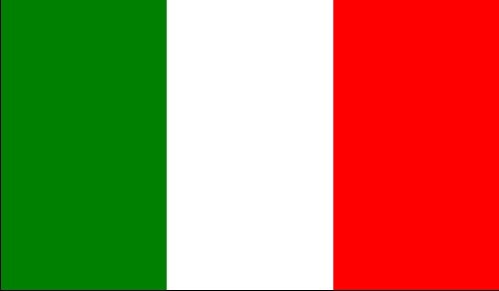 | 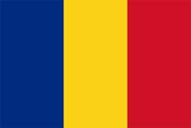 |  | 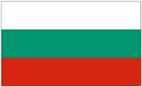
COUNTRY | PORTUGAL | TURKEY | FRANCE | ITALY | ROMANIA | POLAND | BULGARIA
NATIONALITY | PORTUGUESE | TURKISH | FRENCH | ITALIAN | ROMANIAN | POLISH | BULGARIAN
LANGUAGE | PORTUGUESE | TURKISH | FRENCH | ITALIAN | ROMANIAN | POLISH | BULGARIAN
CAPITAL CITY | LISBOA | ANKARA | PARIS | ROMA | BUCHAREST | WARSAW | SOFIA
TRADITIONAL  FOOD | COZIDO À PORTUGUESA,  PASTEIS DE NATA, BOLO REI | KEBAP,BAKLAVA,  TURKISH DELIGHT,  TEA,MANTI,  SARMA,  LAHMACUN, | QUICHE LORRAINE, CONFIT DE CANARD,  STEACK FRITES, GALETTE DE PITHIVIERS | PASTA, PIZZA, MOZZARELLA,  POMODORI.  PROSCIUTTO | FORCE-MEAT ROLLS IN CABBAGE OR IN VINE LEAVES, BULZ,GRILLED MINCED MEAT ROLLS, MOLDAVIAN MINCED MEAT CROQUETTES, COZONAC | BIGOS, ŻUREK  ROSÓL, ROLADY Z KLUSKAMI,  PIEROGI, KABANOSY, OSCYPEK | TARATOR, MUSAKA, SHOPSKA SALAD, BANITSA
HISTORICAL PLACES | UNIVERSIDADE DE COIMBRA  TORRE DE BELÉM  MOSTEIRO DA BATALHA | TOPKAPI PALACE, HAGIA SOFIA, THE BLUE MOSQUE,  ANITKABİR,  CUMALIKIZIK,  DOLMABAHÇE PALACE | CHATEAU DE VERSAILLES, TOUR EIFFEL, CHATEAU DE CHAMBORD | CITTA’ DEL VATICANO, POMPEI, ERCOLANO, PAESTUM, AGRIGENTO, ROMA | THE BRAN CASTLE, THE PELEȘ CASTLE, THE MONASTERIES IN THE NORTH OF MOLDAVIA, THE MONASTERY OF CURTEA DE ARGEȘ, THE HOUSE OF PEOPLE. | GNIEZNO  KRAKÓW,  GDAŃSK ZAMEK W MALBORKU,  ZAMEK KRÓLEWSKI – WAWEL, UNIWERSYTET JAGIELLOŃSKI, | ALEXANDER NEVSKI-MONUMENT, ST.SOFIQ-STATUE AND CHURCH, MONUMET OF VASIL LEVSKI
FAMOUS PEOPLE | VASCO DA GAMA  FERNÃO DE MAGALHÃES  CAMÕES | ATATÜRK,  MEVLANA,  MEHMET the CONQUEROR,  ORHAN PAMUK | CHARLES DE GAULLE, VICTOR HUGO | Leonardo Da Vinci, Galileo Galilei, Giotto, Cristoforo Colombo, Botticelli, Giuseppe Garibaldi | NADIA COMANECI, GHEORGHE HAGI, ILIE NĂSTASE, SIMONA HALEP | MIKOŁAJ KOPERNIK,  MARIA SKŁODOWSKA- CURIE  JAN PAWEŁ II, LECH WAŁĘSA, | VASIL LEVSKI, PAISII HILENDARSKI,  ST.ST.KIRIL I METODII

